Final Exam “Orangehrmlive” (website screenshots)

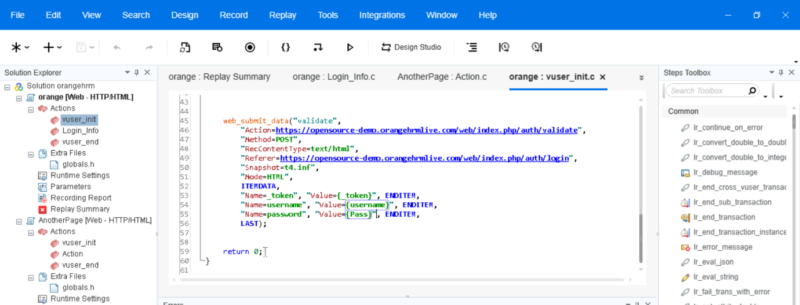

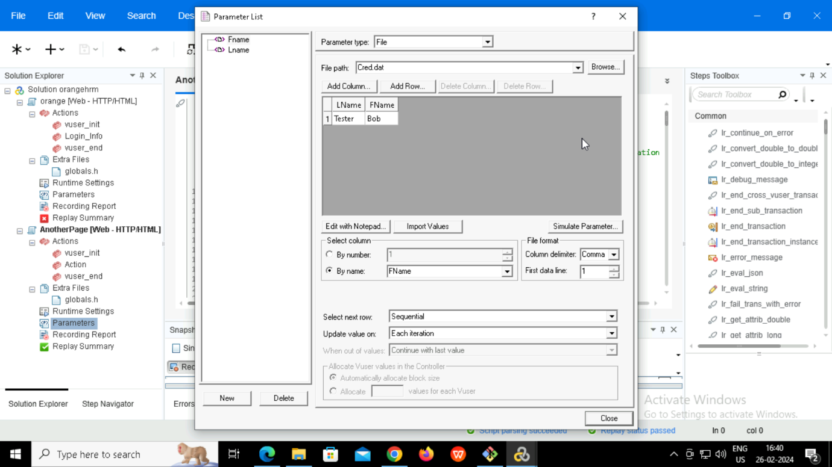

// In first VUGen test(Orange) script, Initially all passed , after the parameterization the script was failed(for login credentials, I done parameterization)during replay. I applied the correlation too.

// For second script all passed, no issues.